PIT - SOP - Prepping Windows devices for Wipe (OOBE)

PREPARED BY
Capri Burns – Project Implementation Engineer

TABLE OF CONTENTS
Pre-Requisites 3
Backup User Data Before Wiping Your Device 4
Initiate the Out of Box Experience on the Device 6

Pre-Requisites
- Devices must be running Windows 11/10 build 1607 or later
- Devices must be running Windows Pro, Enterprise, Pro Education, or Pro Enterprise
- Valid local and domain system credentials are needed to log on to the machine
- (Optional) USB drive

Backup User Data Before Wiping Your Device

Backup User Data Before Wiping Your Device
Before you wipe your device, please follow these steps to ensure all your important data is safely backed up. Neglecting these steps may result in permanent data loss.
- Sign into OneDrive:
  - Ensure you are signed into your OneDrive account.
  - Sync your Desktop, Documents, and Pictures folders to OneDrive.
    - For detailed instructions, refer to Sync files with OneDrive in Windows - Microsoft Support
- Sync Browser Profiles:
  - Sync your browser profiles to save your favorites and bookmarks.
  - Use your company email account (@bjsortho.org) or create a @gmail.com account to synchronize your browsers.
    - For Microsoft Edge, follow the guide: How to Sync Your Browser Across Devices | Edge Learning Center
    - For Google Chrome, refer to: Get your bookmarks, passwords and more on all your devices - Computer - Google Chrome Help
- (Optional) Use an External USB or Hard Drive:
  - As an additional precaution, connect a USB drive or external hard drive to manually transfer important files.
    - Copy your Desktop, Documents, and Pictures folders to the external storage device to ensure you have a backup.
- Verify Backup Completion:
  - Check OneDrive Sync Status:
    - Click on the OneDrive icon in the system tray (bottom-right corner of your screen).
    - Ensure that the status shows “Up to date.” If there are any files still syncing, wait until the process is complete.
    - Open OneDrive in your file explorer and verify that your Desktop, Documents, and Pictures folders are present and contain all your important files.
  - Check External Storage:
    - Open the external USB drive or hard drive in your file explorer.
    - Verify that the copied Desktop, Documents, and Pictures folders are present and contain all your important files.
  - Check Browser Sync:
    - Open your browser on another device or in a different profile.
    - Ensure that your favorites and bookmarks are accessible and up to date.
By following these steps, you can confidently proceed with wiping your device, knowing that your data is securely backed up and protected.

Initiate the Out of Box Experience on the Device

- Power on the device.

- Log on to the device with the local administrator credentials.

- Press the Windows Key + R together to open the Run box:
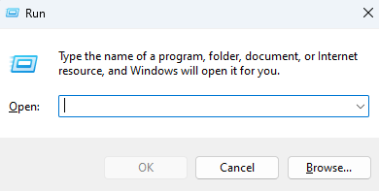

- Type the following command into the Run “Open” field:
- C:\Windows\System32\Sysprep\Sysprep.exe /oobe /reboot

- Press “OK”.
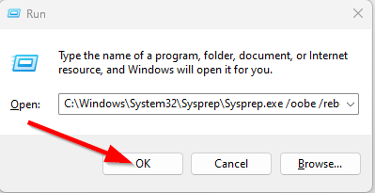

- The system will now reboot into the OOBE state

